Chapter 12 Homework Problems

Problem 12.1

You are designing a bench grinder with an operating speed of 3600 rpm.

1. If you want the grinder to reach its full operating speed in 4 seconds, what must the rate of angular acceleration be in radians per second squared?
2. If the grinding wheel has a diameter of 8 inches, what will the speed of the surface of the wheel be?

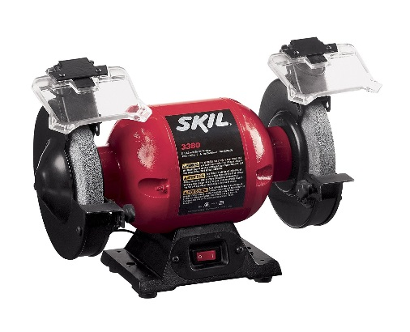

(Solution: , v = 125.67 ft/s)

Problem 12.2

The angular velocity of a flywheel over a 5 second period is shown in the graph below. How many rotations does the flywheel go through during this five second period?

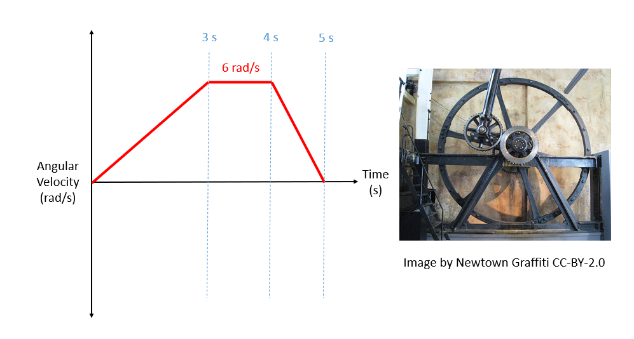

(Solution: )

Problem 12.3

A belt driven system has an input at pulley A, which drives pulley B, which is attached with a solid shaft to pulley C, which drives pulley D. If the input is rotating at 60 rad/s counterclockwise, determine the angular velocity and direction of rotation for the output at D.

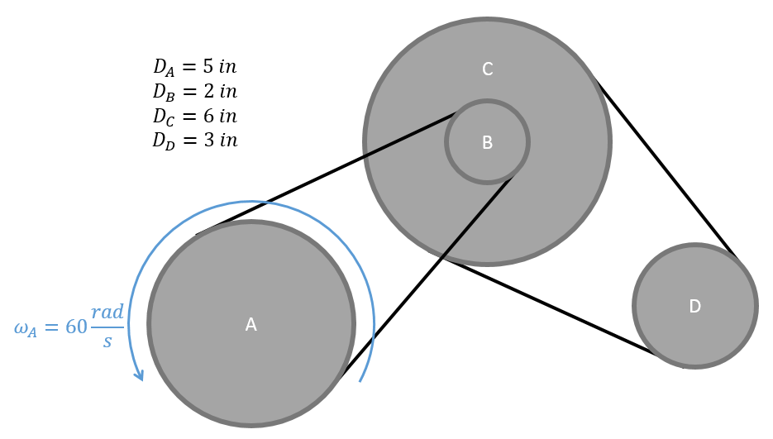

(Solution: counter-clockwise)

Problem 12.4

A gear driven system has an input at gear A, which drives gear B, which is attached via a solid shaft to gear C, which drives the final gear D. If the input is rotating at 2500 rpm clockwise, determine the angular velocity and direction of rotation for the output at D.

(Solution: clockwise)

Problem 12.5

A mechanism consists of two arms of equal length. The mechanism is anchored to the ground at A, and has a roller at C. The roller at C is being pulled to the right at a rate of 1.5 m/s. Use **absolute motion analysis** to determine the angular velocities of arms AB and BC at this instant.

(Solution: clockwise, counterclockwise)

Problem 12.6

A piston in an internal combustion engine is attached to a crank rocker mechanism as shown below. The crank (member AB) has a length of 200mm and is currently at t 20-degree angle. The rocker (member BC) has a length of 325 mm. Assumed the piston at point C is directly above the drive shaft at A. The piston has a downward velocity of 2 m/s, and a downward acceleration of 5 m/s2. Based on this information, use **absolute motion analysis** to determine the angular velocity and angular acceleration of member AB.

(Solution: clockwise, )

Problem 12.7

A trap door is being opened with a hydraulic cylinder extending at constant rate of .7 m/s. If the door is currently at a twenty-degree angle as shown below, use **absolute motion analysis** to determine the current angular velocity and angular acceleration for the door?

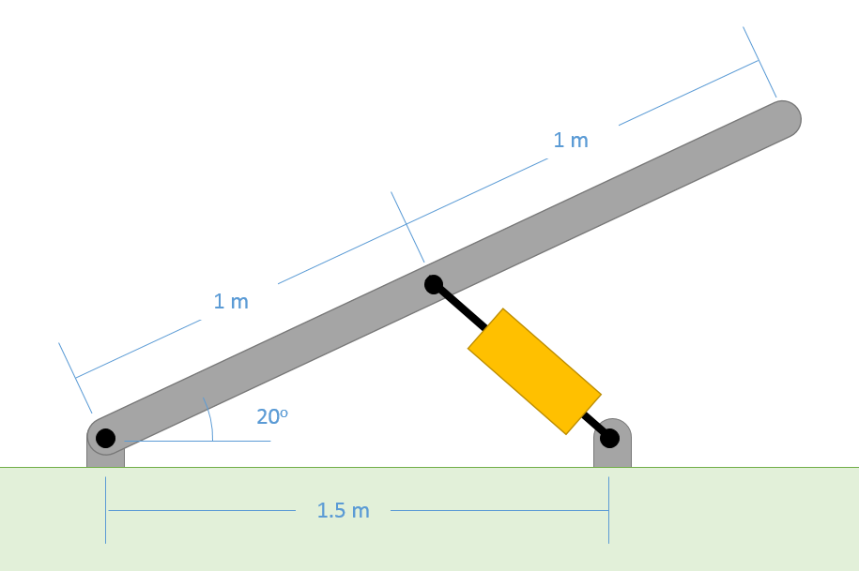

(Solution: , )

Problem 12.8

A robotic arm experiences the angular velocities and accelerations shown below. Based on this information, use **relative motion analysis** to determine the velocity and the acceleration of the end of the arm at C in the x and y directions.

(Solution: vx = 9.44 ft/s, vy = 4.39 ft/s, ax = -33.78 ft/s2, ay = 3.39 ft/s2)

Problem 12.9

A piston in an internal combustion engine is attached to a crank rocker mechanism as shown below. The crank (member AB) has a length of 200mm and is currently at t 20-degree angle. The rocker (member BC) has a length of 325 mm. Assumed the piston at point C is directly above the drive shaft at A. The piston has a downward velocity of 2 m/s, and a downward acceleration of 5 m/s2. Based on this information, use **relative motion analysis** to determine the angular velocity and angular acceleration of member AB.

(Solution: clockwise, )

Problem 12.10

A cart on a movie set is designed to move through the set at a speed of 30 m/s. At the same time, a robotic arm (member AB) will rotate and release a tennis ball such that it has an upwards velocity of 10 m/s while having no velocity in the x direction. Use **relative motion analysis** to determine the required angular velocity and release angle on arm AB to make this happen.

(Solution: counterclockwise, from horizontal)